Nobel Prize Writer Lecture
Title: “In for and filling some other body”

To explain the somehow enigmatic title of my conference, let me quote the full sentence, from English romantic poet John Keats, the author of the famous “ode to the nightingale” extracted from his correspondence with Richard Woodhouse. (1818)

“A Poet is the most unpoetical of any thing in existence; because he has no Identity --he is continually in for -- and filling some other Body --The Sun, the Moon, the Sea, and Men and Women who are creatures of impulse are poetical
and have about them an unchangeable attribute -- the poet has none; no identity --he is certainly the most unpoetical of all God's creatures.”
Reflecting on the definition of poet John Keats, it opens on two domains, quite similar
in effect, if not fundamentally alike in development. One is creation, by words, of a
personal composition. The other is translation of literary works to another language.
Creation and identity
In Keat’s sentence we find a paradox: why poetic invention should be “un poetic”,
and the author “the most unpoetical”? Is not poetry by definition an act of creation
(from the Greek poeien, to make)?
As for the art of translation, if it cannot be totally original, it has nevertheless the
power of recreation, by its capacity and need to commute an expression into another
language.
Then we have to understand the deeper meaning of Keats’ paradox. Using the languageis an interpretation, and is always a work of transposition. In the art of poetry (as
opposed to the story telling, or the research of veracity in history) the poet is opening
the mind to a many-faced meaning, multidimensional in time and space, and to the
secrecy of human mind. The explanation is thus: the poet writes not only with words – meanings, mythems, or reminiscent images – but also with sounds, rhythms, accents. In his treaty on Poetical art the Greek philosopher Aristotle insists on the physical aspect ofthe poetical art, especially on the choice of versification, and on the moral aspect of
catharsis. The word catharsis has precisely the meaning of the flow of words –
cata-rheo, running through – which supports the liberation of the reader’s soul.
Modern creation has kept the idea of sharing with words. In a life accentuated on the efficiency of science and rationalism, poetry has kept the virtues of exploration – we
could call it magic. Or could it be something like presocratic philosophy?
Allow me to quote the intricating verse written by Spanish poet Antonio Machado:
“Caminante, no hay camino, se hace camino al andar. » (Walker, there is no path, the walker makes his path while walking.) A key to the poet’s paradox: writing, as walking, invents its own path.
The other side of poetic creation is in the sharing of a common language. History of
literature has insisted on the role of schools in creation (in narration, or in elaboration ofstyle). We know of so-called classicism and modernity. Of course, the classic composers did not want to be classics. They thought of themselves as modern. Even those who
proclaimed the need to return to classics, like the pre-raphaelites in England, or the
alexandrine in France, were in favor of a new trend, and made it manifest that they
were reinventing something, not copying it. In fact, it is difficult to pin up the essence
of classicism, as humorist novelist Humberto Eco asserted: “A classic, is a book that I
re-read.”
Influence is essential to creation. It can be evaluated in percentage: so much for
cultural knowledge, so much for reminiscences (involuntary returns of one’s readings,
and remains of unidentified rumors), so much for up-to-date, and eventually a very smallpart of personal imagination and invention. This lead John Keats to a pessimistic report: that “there is very little difference in quality between a necessary literary invention and doing nothing.” In that sense the poet is truly the most modern creator of our
contemporary times.
A French-Uruguayan poet, Isidore Ducasse, known by his nom de plume Comte de
Lautréamont, composed in 1868, at the age of 24 the most inventive, provocative,
seditious work, Chants de Maldoror, translated into English as The Maldoror cantos.
This work remained totally unknown to the public, until the surrealists discovered one ofthe few surviving copies of the book, which had been printed at the writer’s expense,
and claimed it to be one of the greatest surrealist texts ever.
Lautréamont never came to know his fame. It was posthumous. He died of exposure in the last months of the 1870 war, at age 26, when the people in Paris had been under siege by the German army, victim of hunger and diseases. In a short collection of his “essays” called simply “Poesies” (Poetry), Ducasse (the name under which he published the collection shortly before his death) claimed that “poetry should not be the work of
one, but the work of all.” Though he probably had no knowledge of John Keats’
writings, he expressed a similar idea. It is not just by chance: the two young men (both died in their early life, before reaching thirty) had the same experience of a closed,
hostile environment, and expressed, each in his way, the skeptic centrality of all
literature – and also their strong craving for an absolute empyrean of poetry.

The quest for identity.
When John Keats puts forward the notion of self-awareness, which is the other name
of identity, he pinpoints the paradox of literature – especially of the poetic art. Using
the common good of the language, a certain language, received at childhood, or acquired during early life, the writer is agreeing to a contract, and at the same time is opening
to freedom of expression. What makes this language his, or hers? How to keep one’s identity in sharing the language? Is this a treason, or at least a sense of practice, a will
to communicate, a compromise? The French symbolist Mallarmé spoke of the “tribe’s
words”- which had to be “purified”.
For the novelist, or the storyteller, the question is resolved by the creation of “characters”, each with a specific language, a way of speaking, an accent, or a way of feeling.
The art of the storyteller is to create identities. At the same time, he or she acts as a
demiurge, with all authority upon the creatures. “Madame Bovary, c’est moi!” used to
boast French novelist Flaubert. (Madame Bovary, she is me)
For the poet, the creation is more complex, it expresses human coherence, and at the same time it modulates the need of identification. Even in the lyrical poetry, of which the best expression would be the Chinese poets of the famed Tang dynasty (650-900), the concentrated form of the verses (Quatrains, and octosyllabs) and the highly restraining rules of the versification, allow the impression of a reciprocating movement between senses, from nature to humans and back. Thus in the poem by Zhang Ruoxu (660-720)

Spring river flower moon night

River and sky of the same color
Not a single flake of dust
Shining in the middle of the void
The solitary wheel of the moon
On this shore who is the man
Who first looked at the moon?
Moon above the river in what year
Did you shine over men for the first time?
The destiny of mankind along the ages
Never will know its end
Moon over the river age after age
You are always the same
Who knows what soul waits
For the moon above the river?
We see only the long river
Flowing down with its waters.

The question of identity is crucial for modern poetry. It has gained over the criteria
expressed in Aristotle Poetic art, which were linked to morals. For the oriental worlds (meaning China, Korea, Japan) the need to respect moral rules has kept pace until recenttimes. The Confucean definition of poetry, as a melodic lesson of good will and good
behavior (we have to remember the famous poem The two doves that the Master quoted as an example of perfection) has prevailed over the need to express the deepest layers ofhuman consciousness. *
(quoting the poem)

The sentence of John Keats is for us central, because it underlines the fact that
identity is out of reach. The human mind, in free exercise in poetry – even more with
the disappearance of versification rules – expresses versatility, rapidity, uncertainty. In
fact poetry in modern times expresses the new ways of science, philosophy, knowledge. It is in accordance with the reign of life, where the rules of the game have changed so much: it shows the non linear more than the chronological, the prevalence of disruption over continuity, and the evidence, everywhere, of what we call Hasard (fortune, or
chance). The word by itself has a very poetical origin, as it reminds us of the game of
dice practiced in all orient, when the winning face of the dice bore the image of the
orange flower (in Arabic As Zahar)
The epitome of the theory of Hasard in literature shows in a rare book published in 1980 by French humorist Raymond Queneau, which he called simply Mille milliards de
poemes, One thousand billion poems, written in classic alexandrine (duodecasyllables)
each verse cut in such a way that it can compose with the fourteen other verses of the
sonnet, and each time gives a different poem. Of course, the demonstration is more on the side of excentric than of true creation. Still, it shows a mental derivation from
everything considered up to now as the essence of poetry.

Filling one’s own body

By a natural swinging, our contemporary times have favored another idea of poetry – that which had been the inspiration to great poets of the Tang dynasty in China, like Du Fu, Li Bai or Li Shangyin. Under the influence of great thinkers like Meng Zi, Kong
Zi and Mo Zi, the poets ventured far from the stylistic environment and expressed their concern for their contemporary, in a time of civil war and injustice.
A great feeling of compassion inspired their poetry, when the poor peasants suffered
from hunger, abusive conscription, and abandoned. The life of a simple woman becomes the subject of a poem, in Li Bai’s verses:

At age fourteen I became a woman
I used to hide my face out of shyness
Face down, always looking at the dark wall
I dared turn to you only after thousand calls
At age fifteen I came out of my shame
I wished to share with you the dusts of life
I swore I would die before renouncing our vows
Now who knows if one day I shall be waiting for my husband in vain?

The modern times have been under the rule of reality: poetry, as for the novels and the paintings, dedicated its works to the partaking of human beings, following the raise of democracy and justice.
The so-called raise of commitment literature (Steinbeck, Dos Passos, Zola, Dickens)
has been an inspiration for poets, like TS Eliot in his celebrated elegy to the Waste
land, devastated by the war, mixing styles, languages, rhythms. The most emotional of
the commitment poets is Korean Yun Dong-ju, assassinated by the Japanese colonial
army, and his words engraved on the slopes of Mont Hansan in Seoul, celebrating the
beauty and the hope for a free life:

D'une âme chantant les étoiles,
je m'en vais aimer toute forme de vie
Il ne me restera plus qu'à suivre la voie qui m'a été tracée,
Cette nuit encore, le ciel est parsemé d'étoiles. »

(With a soul singing to the stars
I am going to love all forms of life
All I shall have to do is follow the path given
Tonight, once more, the sky is scattered with stars)

However, the great change in poetic expression is undoubtedly the raise of feminist
literature, both in poetry and story-telling. Everywhere in the world, in all languages andcultures, women are the representants of a social revolution. They have picked up the
torch of commitment where it had been laid down by men. In a celebrated collection of poems, Zhai Yongming, an authoress born in Shanghai in 1980 has claimed for the
freedom of women all over the world; her collection is simply entitled “Women”. When needed, her writing becomes vengeful and straight to the fact: because it is urgent,
needed, and there is no more time for periphrasis and convoluted sentences

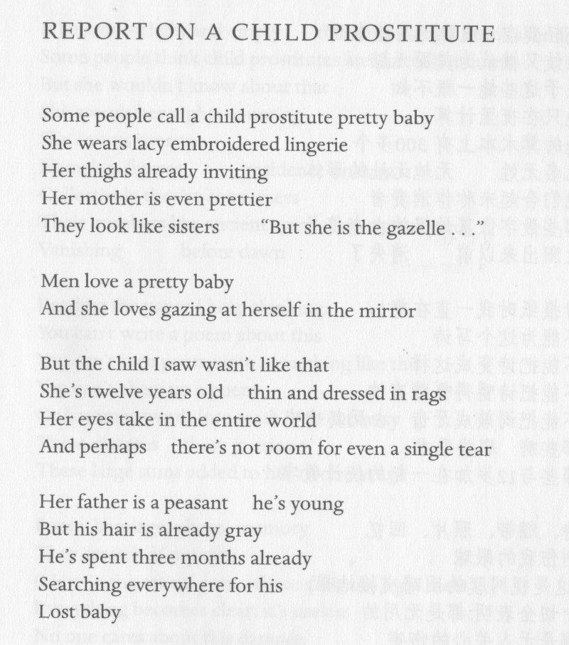

Filling some other body

Traduttore, tradittore, says the italian refrain. Translation, treason. The saying might be justified. The example of the conquest of Mexico by the Spaniards under the command of captain Hernan Cortes gives the proof. When the Spaniards reached the new world, they were confronted to indigenous people to whom they could not speak. By chance (but bad luck for the local) the Maya Indians kept among them a captive woman, belonging to the Aztec tribe, who had learned a few words of Spanish with two Spaniards, who shipwrecked and taught her their language. Thanks to this woman captive, Hernan Cortes was able to speak with the indigenous, collect information, make alliances, and eventually conquer the whole kingdom of the Aztecs. Cortes made her his mistress, had a child with her, and finally repudiated her and gave her to one of his soldiers. She has been celebrated under the name of Marina, in the Aztec language she was known as the « Malinche », a depreciative knickname deserved by the role she had played in the destruction of her own people. Until today, hijo de la Malinche, son of the Malinche is the worse abuse in Mexico.
Translating is not only a weapon for conquerors. It allows also meeting between cultures, future exchanges, and benefits. Translating is built on the idea of transfer. Translating is not only a question of vocabulary. It leads also to accept the other, try to guess, feel and live like the other. It means inventing the other, familiarize with another decor, another neighbourhood.
It is not just a question of learning by heart vocabulary and syntax. How to translate the use of auxiliaries, the expression of time, movement, the personal pronouns, the play with sounds, the taste for agglutinated, composed names? How to translate all the flexions, modisms, the short particules (the linguists name them struments) which add nuances to the meaning, respect, politeness, irony, emotion, and even sex and age? Reading in another language signifies a trip back and fro, an hesitation, an intuition.
For all these reasons, translation, and reading in another language mean recourse to passion, a feeling that has nothing in common with semantics. When I read poet Kwak Hyon-hwan or novelist Han Gang, I change my identity, and my korean self is revealing itself.

As I have mentioned the role of Dona Marina, the « Malinche », during the conquest and destruction of the Aztec empire, in 1540,
I should like to recall for you a personal experience. I was at university of Oklahoma in Norman (United States) some twenty years ago, participating to a colloque on translation. After several communications, most of them quite abstract and technical as usual, a person took part to the discussion. She was an old lady, member of the Mohawk tribe – called in the US the « Five civilised tribes » because they had accepted the colonization of the Europeans in spite of the sufferings. Her name was Aleece Gerhardt, she was heir to some petrol fields in Oklahoma, and had participated economically to the organization of the Colloque. She was kind of shy in spite of her rank, so she did not dare speak in public. Instead, she wrote a question on a leaf of paper and passed it to the tribune. On the paper was written a simple question, in the interro-negative form familiar to indigenous people in America: « Is not the translator putting the translation at the feet of the author? »
As we were all surprised by her question, we could not give any answer. What was the meaning of her expression « putting at the feet »? Only moments later, after the end of the session, the sense of her question stroke me: what she meant by « putting the translation at the feet of the author » signified that there cannot be a valuable translation (in literature, or in life) without a sharing of respect and care. As if there was something of a sacrament in the act of translating.
I would like to link Ms Aleece Gerhardt original remark to the quest for truth and partaking implicated in the words of John Keats, and quote a brief passage of the « Ode to a nightingale », admirable metaphore of the poet’s solitude and devotion:

Already with thee! tender is the night,
And haply the Queen-Moon is on her throne,
Cluster'd around by all her starry Fays;
But here there is no light,
Save what from heaven is with the breezes blown
Through verdurous glooms and winding mossy ways.

Creation , like translation, is an adventure of the mind, infirming the enclosure in oneself, and requiring the need of filling some other body.

J.M.G. Le Clezio, july 2025

